**Java Nine Men’s Morris User Manual**

By: Kevin Yu and Yash Balwanti

**Objectives & How to Play:**

**Objective:**

The objective of this game is to take all of your opponents pieces before they take yours. It’s that simple!

**Things to Keep in Mind:**

The instructions are a bit more complicated than the objective. Some things to keep in mind before we dive into the game:



1. The blacked out boxes **ARE NOT PLAYABLE SPOTS**. They are just filler blocks to make the board.
2. At the top you and your opponent may change your names by typing in your name in the box and clicking on the change _____’s name button.
3. The white boxes are playable and that is where you will be placing and moving your pieces throughout the game.

**Some Rules:**

* All players start with 9 pieces
* If somehow the opponent only has pieces in rows and no singles are left to remove, restart the game.

**Phase 1 of the Game:**

Now that we have covered the features of the game, we can start the game. Phase 1 of the game is played as follows:

* Players will go back and forth placing pieces on the board with red starting and yellow following.

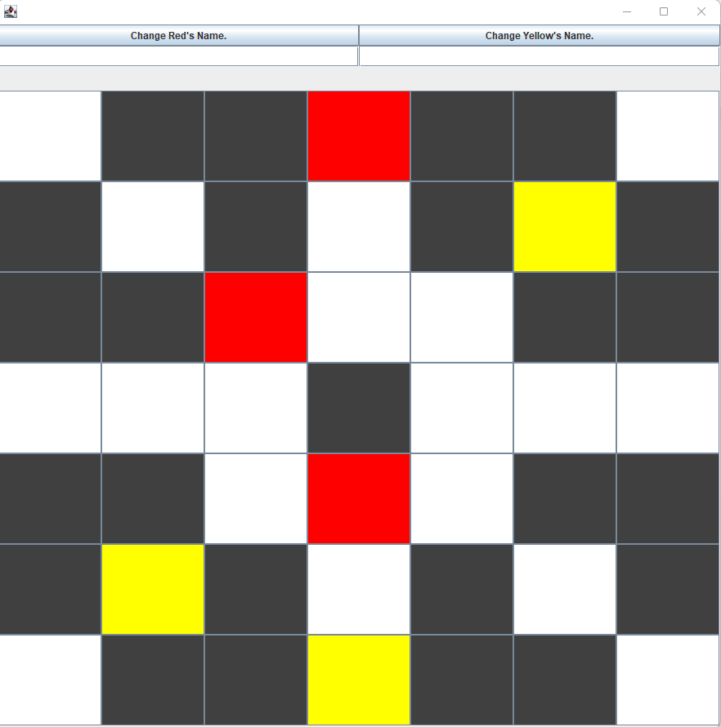

* If a player were to get 3 in a row of his pieces, he may remove a piece from the opponent that **DOES NOT EXIST IN A 3 IN A ROW.** For example:

This you may do:

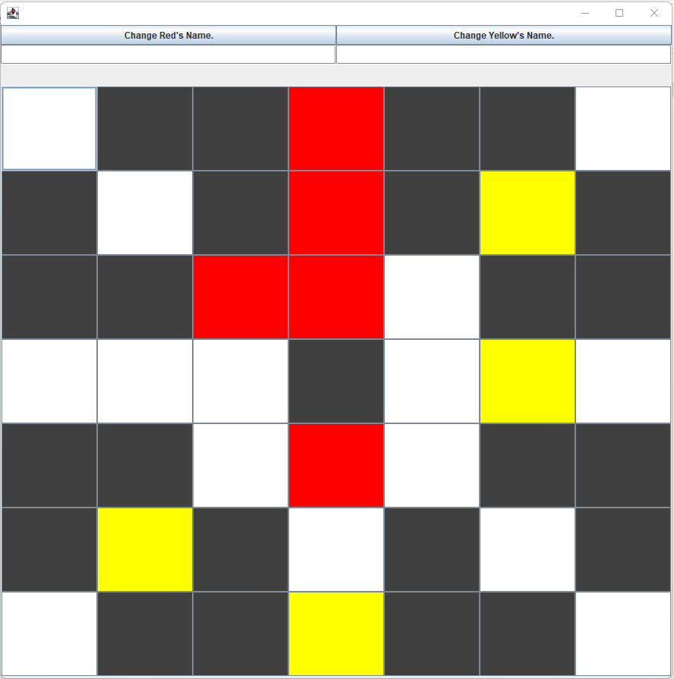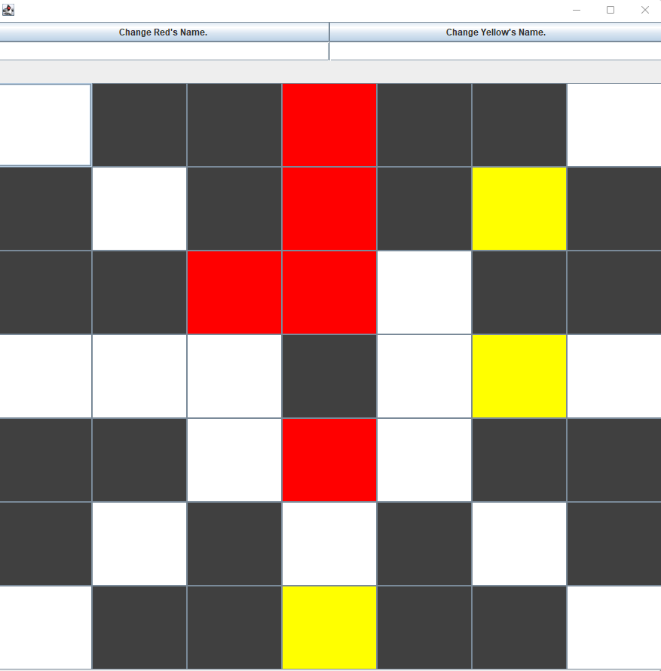

If you make an illegal move, the program will tell you :

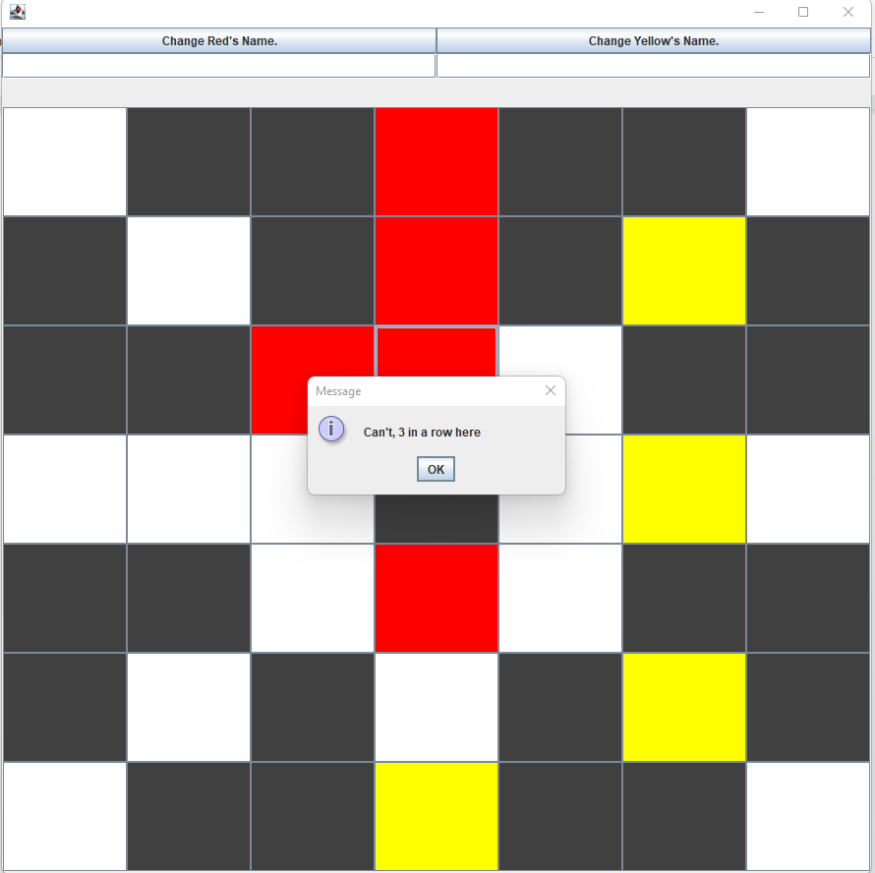

* Phase 1 ends when each player plays their 9 pieces. It will then prompt that phase 1 is over and phase 2 has commenced.

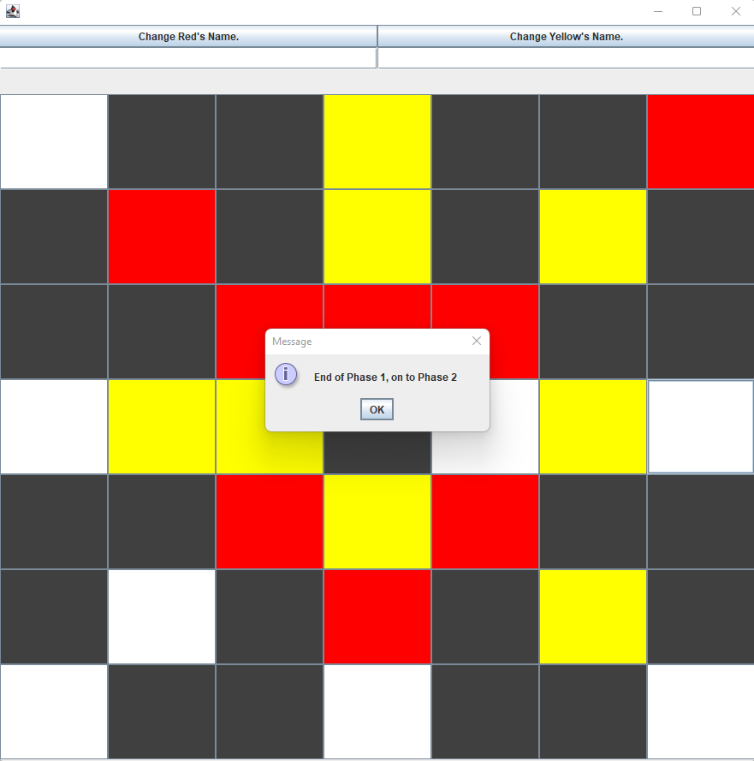

**Phase 2 of the Game:**

Now that all the pieces have been placed, it’s time to move them. Phase 2 of the game will be played as follows:

* Players will again take turns moving pieces with red starting and yellow following.
* When moving, you may only move to adjacent spots moving vertically or horizontally (See the black boxes as an open space when moving. You can’t move there, but you can move across them).

Example( Red top corner moves down):

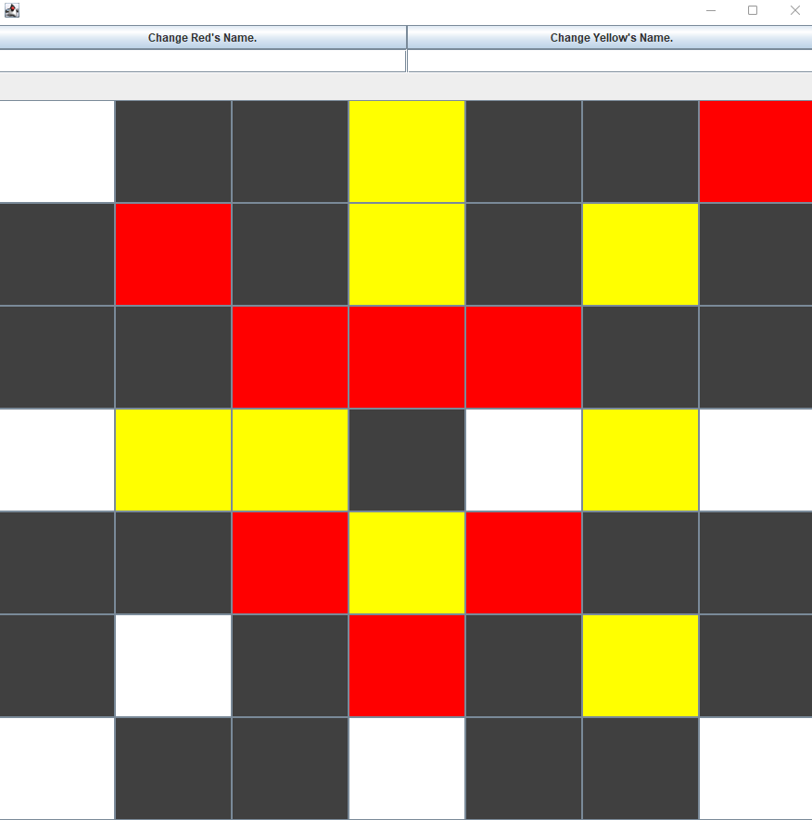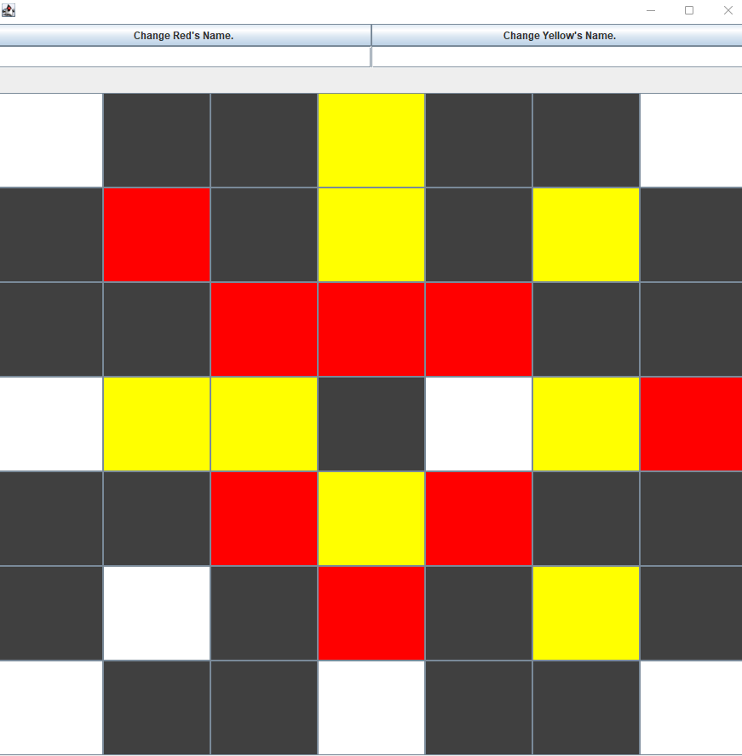

* Like before, it will prompt you that you have made an illegal move if you were to move incorrectly or if you moved on the opponent's turn.

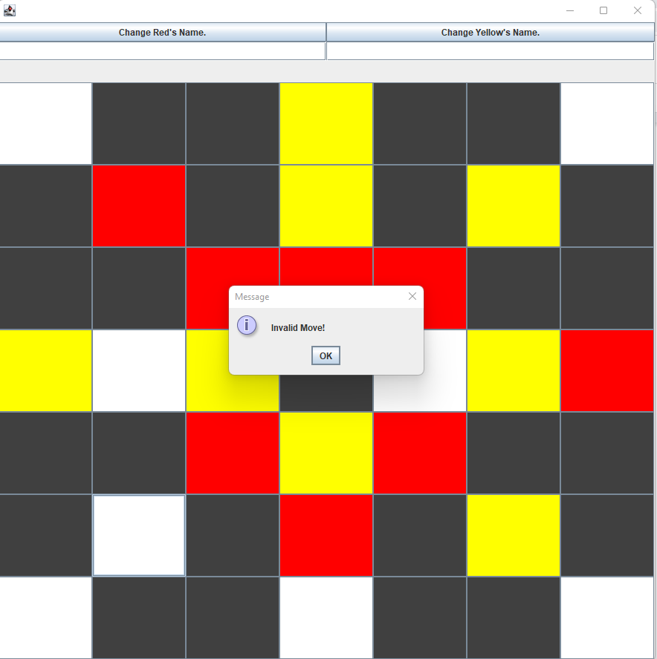

* Same rule of removing pieces applies. If you were to achieve 3 in a row, you are able to remove the opponent's piece.

**Phase 3:**

* When a player has 3 pieces remaining, they are allowed to “fly” and hence move their pieces anywhere on the board that is not occupied by the opponent.
* Only the player with 3 left may do this and the other will still play in phase 2 until they reach 3 pieces as well.

Example:

Red moves from (2,2) to (6,3)

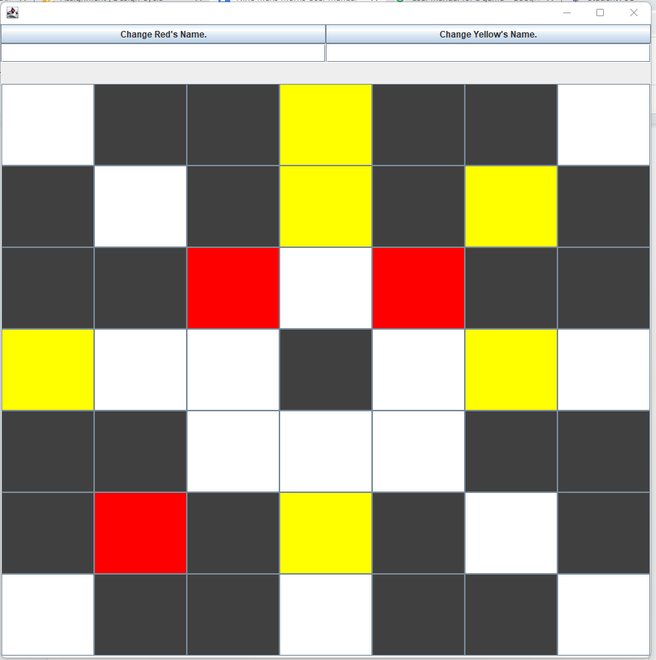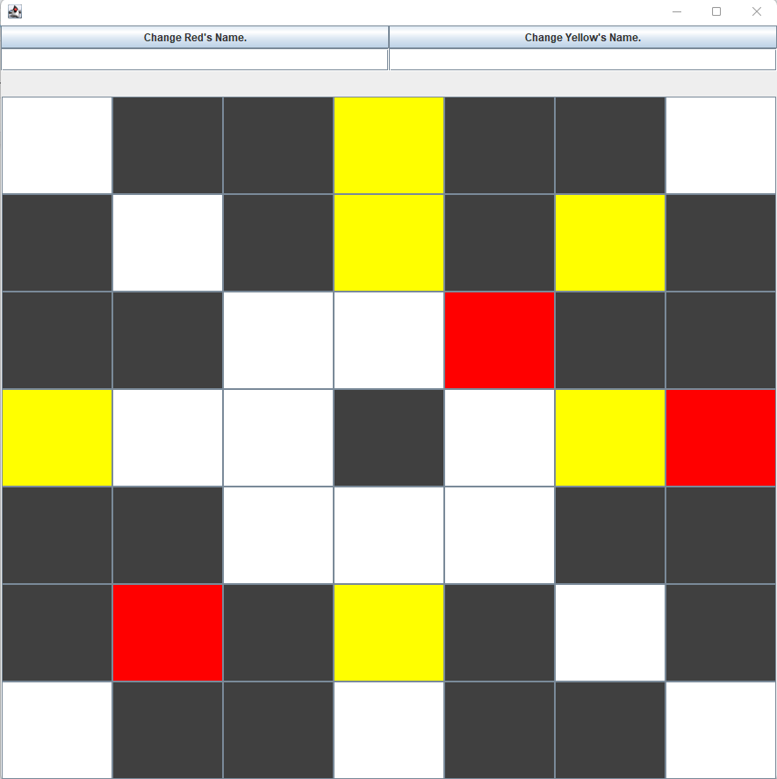

* Once again, you may remove pieces if you were to achieve 3 in a row and you may not remove pieces in a 3 in a row.

**The End:**

The game ends once a player has only 2 pieces left.

